English |  | Maths | Science |  | P.E
We begin the half term researching about volcanoes and earthquakes and write our own explanatory text.  We then move on to a unit based on our class novel which recaps diary writing and instructions before looking at the features of play-scripts  We finish with a fun unit on imaginary creatures where we use our skills of persuasion to explain…  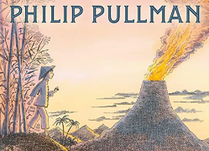  Why my animal is the most amazing animal ever to live!  The children will have discrete Spelling Punctuation and Grammar (SPaG) tasks and will be given a set of spellings to learn each week.  Whole Class reading or small group guided reading will take place each day and will include a range of non-fiction texts to support their learning across the curriculum in addition to our class book. ‘The Firework Makers’ Daughter’ |  | Throughout the year the children will be focusing on mental maths, and instant recall, including times tables.  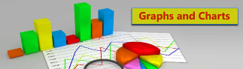  Core Maths lessons with focus on the topics following topics…  Statistics  Angles  Shape including triangles | We will look at different types of rocks and how they are made (like igneous, sedimentary, and metamorphic).  We will compare and group rocks based on things like appearance and hardness.  We will test which rocks are good at letting water through (permeable) or not.  We will learn how fossils are formed in rocks.  We will explore how soil is made from rocks and organic matter. |  |   PE is taught on a Tuesday afternoon with Mrs Cooper  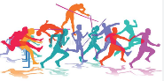  and again on a Thursday afternoon by our sports coach.  This half term we will focus on Swimming and athletics.
 |  | Holly Class  Summer 2  Drop, Cover and Hold | Humanities |  | Computing
 |  | Holly Class  Summer 2  Drop, Cover and Hold | We will learn that the Earth’s surface is made of plates that can move and that volcanoes happen when magma (hot, melted rock) escapes from inside the Earth. We will explore the different parts of a volcano (crater, cone, lava, magma chamber). We will find out why some volcanoes erupt often and others stay quiet for a long time. In addition will find out that earthquakes happen when the Earth’s plates move and shake and that they can change the land and sometimes cause damage. We will also discover how people stay safe during earthquakes and why people live near volcanoes. |  | Our e-safety this term focuses on making appropriate lifestyle choices.  We will also learn how to use Stop-Frame Animation  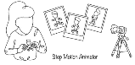  We will take lots of photos of objects, moving them a little bit each time. When we join the photos together, they will look like a mini movie. We will edit our animation to help it tell a story.
 |  | 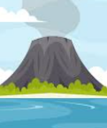
P.S.H.E | Focuses on ‘Embracing the Moment” |  | Art | - We will continue to combine shapes together to make an interesting free-standing sculpture.
R.E | We continue to learn about the following Muslim beliefs  Islam – Muslims believe Islam means peace through following God (Allah). It is about living the right way, praying, helping others, and following the teachings of the Prophet Muhammad peace be upon him). Iman – This means faith or belief. Muslims believe in one God (Allah), angels, holy books, God’s messengers, the Day of Judgement, and life after death. |  | D & T | We will continue to make different frame structures in lots of shapes and sizes. We will design a pavilion that is strong, stable, and looks good. We will choose the best materials and building methods to make it stand up. We will learn how to add cladding (coverings) to make our pavilion even better.
Music |  |  | Spanish |   The key topic will be words associated with ‘The Classroom’, learnt through song and spoken language.

