English |  | Maths | Science |  | P.E
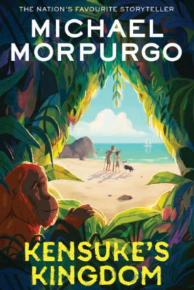  During this half terms unit of work based on Kensuke’s Kingdom we look at balanced arguments, newspaper reports and letter and diary writing.  The children will have discrete Spelling Punctuation and Grammar (SPaG) tasks and will be given a set of spellings to learn each week.  Whole Class reading or small group guided reading will take place each day and will include a range of non-fiction texts to support their learning across the curriculum in addition to our class book. ‘Kensuke’s Kingdom’ |  | Throughout the year the children will be focusing on mental maths, and instant recall, including times tables ready for the MTC test. This half term see the last push to attain instant recall of all tables facts to 12 x 12 ready for the assessment that takes place after half term.  The focus for core Maths lessons will be… Position, Symmetry and Time | We will sort materials into solids, liquids, and gases. We will watch how some materials change state when they are heated or cooled. We will find out the temperature this happens at, measured in degrees Celsius (°C).  We will learn about the water cycle:  Evaporation – water turns into gas when it gets warm. Condensation – gas turns back into liquid when it cools. We will see how temperature changes can make evaporation happen faster or slower. |  | PE is taught on a Tuesday afternoon with Mrs Cooper  and again on a Thursday afternoon by our sports coach.    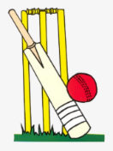  This half term we will focus on Tennis & Cricket
 |  | Holly Class  Summer 1  Local Study | Humanities |  | Computing
 |  | Holly Class  Summer 1  Local Study | We will carry out a local study of Ditcheat using simple fieldwork and observational skills to study the geography of the school and its surrounding environment, including identifying and understanding its basic human and physical features. This involves developing geographical tools and skills, using maps to describe locations, and understanding how the local environment changes over time. |  | Our e-safety this term focuses on making age appropriate choices.  We will also use a block-coding program to make a simple game. We will learn about loops, count-controlled loops and Infinite (forever) loops.  We’ll test which loop works best to make our game fun and smooth.
P.S.H.E | Focuses giving to others. |  | Art | - We will combine shapes together to make an interesting free-standing sculpture.
Music | 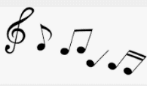 |  | D & T | We will make different frame structures in lots of shapes and sizes. We will design a pavilion that is strong, stable, and looks good. We will choose the best materials and building methods to make it stand up. We will learn how to add cladding (coverings) to make our pavilion even better.
R.E | We learn about the following Muslim beliefs  Islam – Muslims believe Islam means peace through following God (Allah). It is about living the right way, praying, helping others, and following the teachings of the Prophet Muhammad peace be upon him). Iman – This means faith or belief. Muslims believe in one God (Allah), angels, holy books, God’s messengers, the Day of Judgement, and life after death. |  | Spanish |   The key topic will be words associated with habitats, learnt through song and spoken language.

